**Login to ESX host with putty using root credential.**

Type the command: - To get the information of SD Card

esxcli storage core device list | grep -A27 mpx

**Model – Internal Dual SD /Flash Highlighted in the below screenshot**

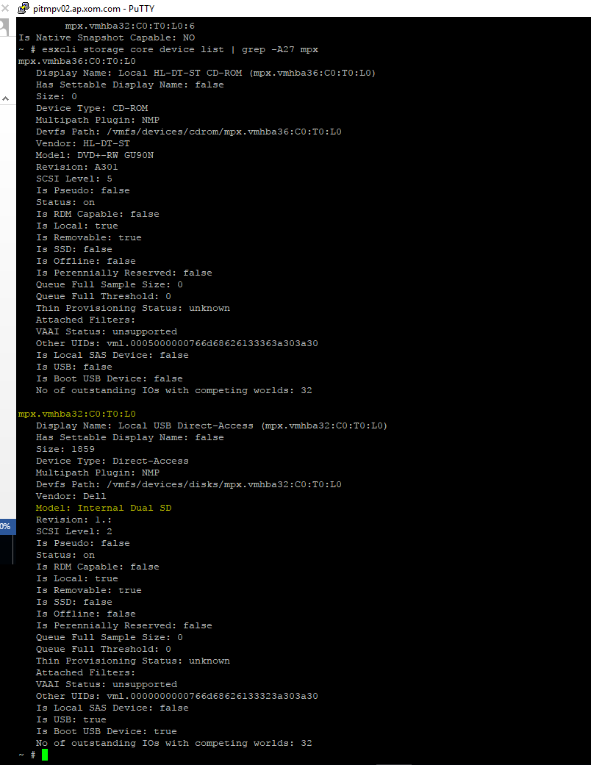

Then type the command:-

ls -la /bootbank

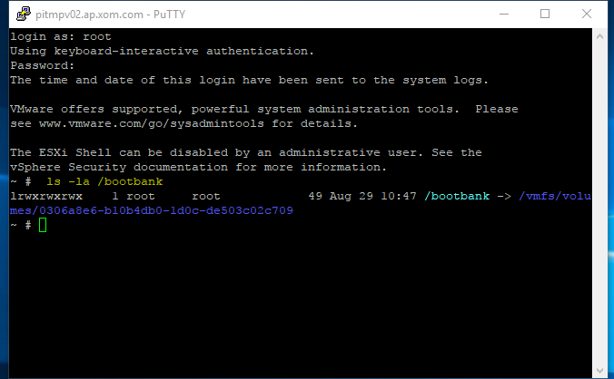

Then type the command:-

vmkfstools -P (copy the UUID boot bank path highlighted in blue)

vmkfstools -P /vmfs/volumes/0306a8e6-b10b4db0-1d0c-de503c02c709

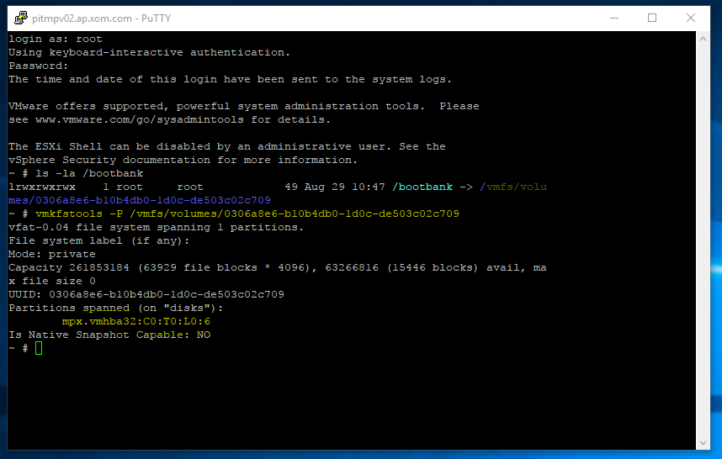

Here we can able to see the Esxi installed (**mpx.vmhba32:C0:T0:L0:6** ) this is same as first screen.